Performance Evaluation of Multi Point Bore Well Systems in Coastal Fields of Bapatla
Dr. H.V. Hema Kumar, Dr M. Raghu Babu, Er. K. Krupavati & Er. K. Kishan
Abstract
Lack of irrigation water from two major sources i.e. rainfall and improper release of canal water resulted in installation of 400 to 500 multi-pointbore well systems by the farmers nearby Bapatla during the year 2002 with the help of local technicians. The efficient use of ground and fresh water depends upon spacing of these wells and aquifer characteristics.Due to over exploitation of fresh water there is intrusion of saline water and deterioration of fresh water. Hence the study was carried out to study on number of hours of pumping, change in water quality during pumping, discharge draw down relationships, aquifer characteristics like transmissivity, specific yield and storage coefficient etc. SATEM-2002 software package was used to estimate the properties of the water bearing strata. The study revealed that pumping in short duration i.e. 3 to 4 hours has not shown much change in water quality. It was noticed that the drawdown variation in the observation well is found to be considerable. The radius of influence for the aquifer is varied from 15 to more than 40m. The aquifer transmissivity for test site 1 and 2 were found to be 676.5 and 396.4 m²/day under time drawdown analysis (Theis-Jacob method) and 393.4 and 3335.8 m²/day in distance draw down analysis. Similarly the specific yield is found to be 6.25 and 3.78 in time drawdown analysis (Theis-Jacob method) 6.92 and 5.96 under distance draw down analysis.
Key words: Multi-point bore well systems, aquifer, SATEM-2002, Specific Yield
Introduction:
There are 1.74 lakh hectares of sandy soils along the sea coast of Andhra Pradesh, in which water table varies at a depth of 0.3 to 3m. In coastal sandy soils of Andhra Pradesh, farmers traditionally draw out fresh water manually from 4-5 dug out conical pits (locally called doruvu’s) in each acre of land. These doruvu’s waste about 20% of the productive coastal lands and are also have high evaporation losses.Also due to increased pressure on usage of more water for domestic, irrigation and industries, there is intrusion of slain water and deterioration of fresh water. In the condition of less annual rainfall, farmers change their cropping pattern from paddy to vegetables and pulses. Due to less rainfall, non-release of canal water, farmers depend on ground water by installing a battery of two/three point bore wells and tapping fresh water. This technology is easy to install and cheap. The discharge and drawdown for an infinite array of wells placed parallel to a line source could be approximated (Kunkel1960). But it is also important to know technical aspects like number of hours of pumping, change in water quality during pumping, aquifer characteristics like transmissivity, specific yield and storage coefficient etc. The drawdown at any point in multiple well point is equal to the sum of drawdowns due to pumping in each individual wells. Boonstra and Kselik, ILRI, Wageningen(2002) developed SATEM software for aquifer test evaluation by which the unsteady state drawdown discharge calculations can be performed graphically and analytically using Hantush-jacob, Theim-Jacob equations. The present study was carried out during summer months in Gudavalli village with an objective to evaluate performance of multi well systems at different farmers’ fields and was analyzed with SATEM 2002.

Materials and methods:
The studies were carried out at Gudavalli village of Guntur district with an objective to conduct pumping tests to analyze discharge draw down trends and to carry out geo hydrological studies for knowing aquifer characteristics. Gudavalli is situated between 15⁰ 50’ 50” and 16⁰ 50’ 00” north latitude and 80⁰ 25’ 00” and 80⁰ 50’00” longitude. A two point bore well system (Test site –I) and three pointbore well system (Test site –II) were already installed in different farmers field was used for study. The distance between two bore points is 9 ft in case of two point bore wells and it is 10 ft in case of three point well point system as shown in Fig 1 &2. The fluctuations in ground waterwere observed in observation well installed at the site with 4 inch auger hole. The observations were measured with the help of electronic sounder. Mechanical analysis was carried out to estimate quantities of sand, silt and clay by using hydrometer method. EC_{e} and pH was determined by the saturation extraction method as described by Jackson (1967). During the experiments and as well as at the farmers sites it is evidenced that using 5 hp motor, the water can be pumped for a continuous period of 3-4 hours only.
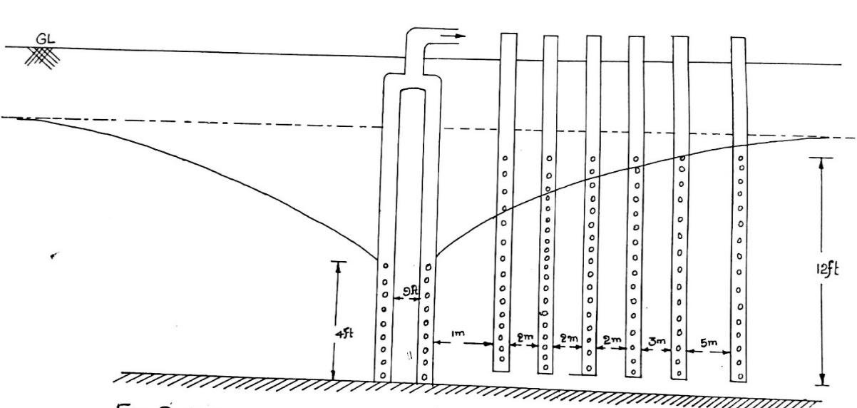
Fig. 1. Layout of two point bore well system
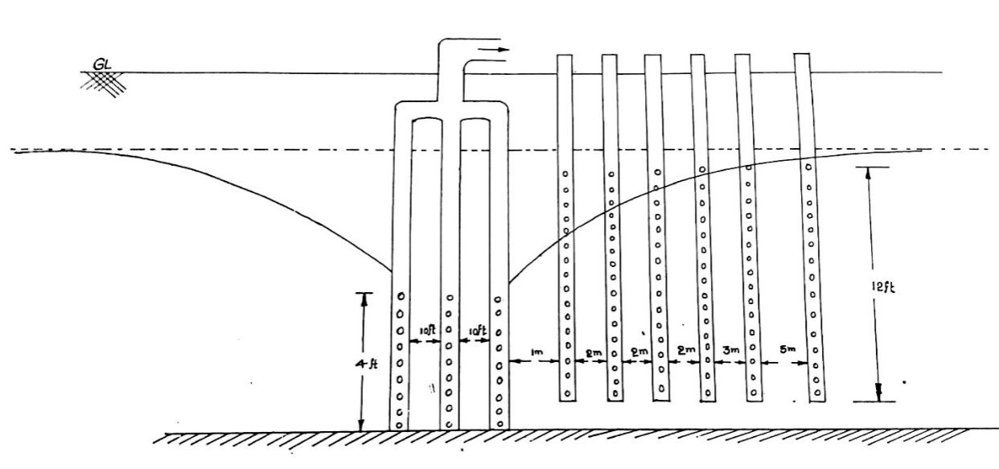
Fig. 2. Layout of three point bore well system
SATEM-2002 software package was used to estimate the properties of the water bearing strata. In SATEM-2002 software, in a time draw down analysis, draw down data using pumping from each observation well was used. In time recovery analysis,the measurements after the pump has been shut down can be obtained for the piezometer. In present analysis, to suit the field situations as the formation is unconfined, and unsteady state pumping, time drawdown and distance drawdown analysis were chosen to arrive the aquifer parameters. The following standard equations have been used in the software to draw log-log plots between well functions and drawdown graphically and analytically.
Theis equation:Theis (1935) was developed an equation for unsteady state flow which introduced the time factor and storativity. It is written as
$$S\left(r,t\right)=\frac{Q}{4πKH}\int_{u}^{α}{\frac{e^{-y}}{y}}dy= \frac{Q}{4πKH}W(u)$$
Where s(r,t) = drawdown measured in a piezometer, m
r= distance between piezometer from the pumped well, m
t = time since pumping started, day
Q= constant well discharge, m3/d
KH = transmissivity of the aquifer, m2/day
W(u) = Theis well function (-)
S = storativity of the aquifer (-)

Theis-jacob: The theis well function is plotted against 1/u on semi log paper. The figure shows that for large values of 1/u well function is a straight line. This can be written as
$$S\left(r,t\right)=\frac{2.3Q}{4πKH}log⁡( \frac{2.25KHt}{r^{2}S})$$

Theim-jacob: Developed an equation for confined aquifer and when time drawdown curves for different observation wells are parallel. It is written as
$${ S\left(r_{1},t\right)}_{m}-{S(r_{2},t)}_{m}=\frac{2.3Q}{4πKH}log⁡( \frac{r^{2}}{r_{1}})$$

Results:
Observations made, data collected and analyzed in accordance with the objectives of the study. The discharge while pumping has been measured volumetrically in hourly interval along with the depth to water levels in all the observation wells. The data pertaining to the drawdown while the pumping is recorded in all the observation wells installed near the multi-point bore well systems are presented in table 1 and 2. The pumping experiments were conducted during March and April months. At two point well system, as per tests conducted on 11th March, the water level from the ground varied from 1.38 to 2.58 for a period of three hours and recharged to a depth of 1.6 m only in two hours which is an indication that the system yield is less than the pumping rate. Similarly at the farthest observation well, the depth varied from 1.42 to 1.60 m and recharged up to 1.59 m within two hours. Similar trends (Fig 3 to7) were observed on remaining two dates also. In all the tests it was noticed that the drawdown variation in the observation well i.e 15 m apart is found to be 4 to 5 cm, which clearly indicates that radius of influence for the aquifer is few meters.
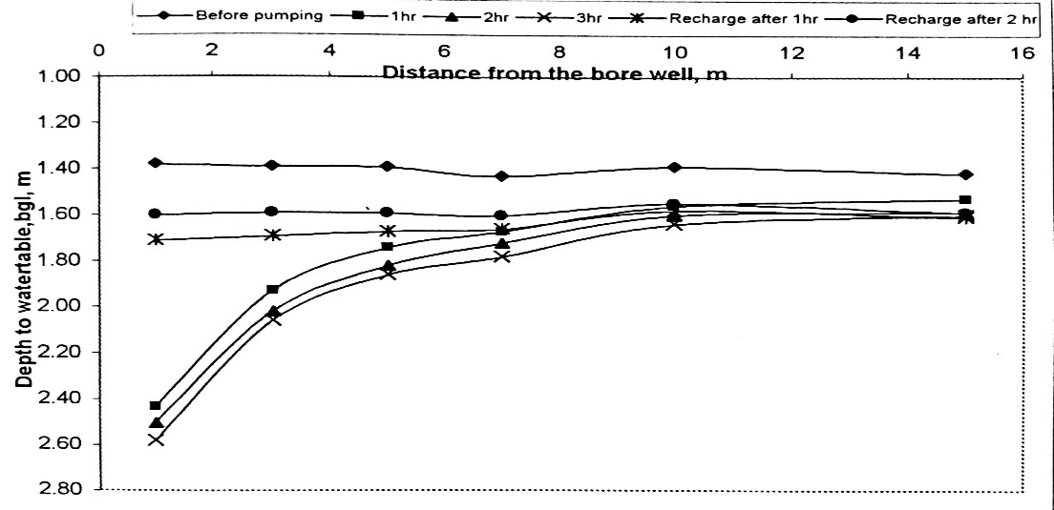
Fig. 3. Drawdown curve at test site –I

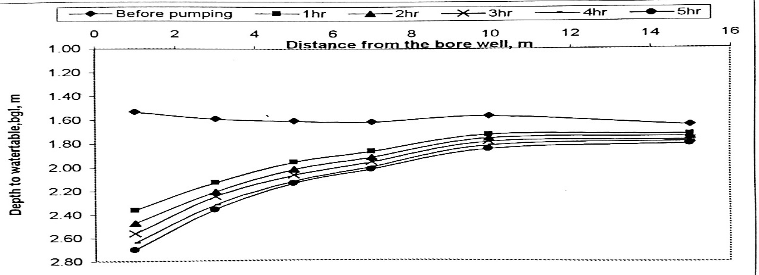
Fig. 4. Drawdown curve at test site –I
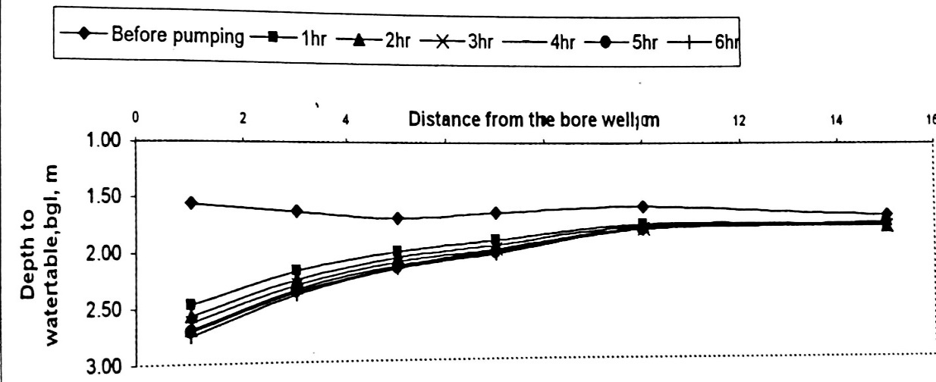

Fig. 5. Drawdown curve at test site –I
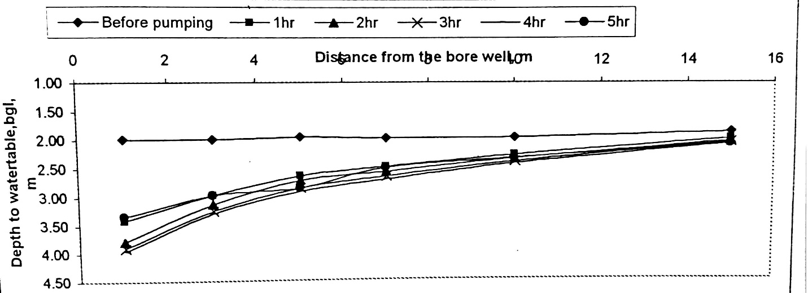

Fig. 6. Drawdown curve at test site –II

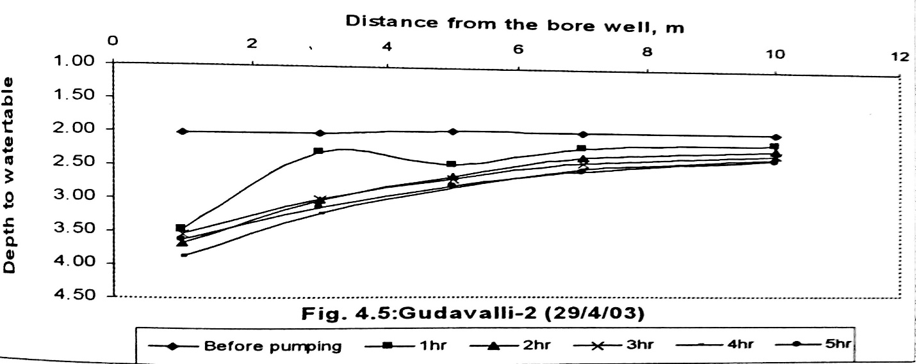

Fig. 7. Drawdown curve at test site –II
At three point bore point well system, as per the test conducted on 7th April, the water level from the ground varied from 1.99 to 3.34 m for a period of 5 hours. Similarly at the farthest observation well, the depth varied from 1.87 m to 2.08 m. The same is graphically representation fig6. Similar trends were obtained for the experiments conducted on 29th April. In the tests, it was noticed that the drawdown variation in the observation well is found to be considerable i.e on the order of 21 to 39 m. Which indicates that the radius of influence extends further and it needs the installation of the observation well at about 40 m also for accurate aquifer data to arrive at a particular safe storage capacity of the aquifer.
Aquifer test analysis using SATEM-2002 software:
The discharge while pumping has been measured volumetrically in hourly interval along with the depth to water levels in all the observation wells. To arrive at the aquifer parameters, the SATEM software has been used with two options available in the software namely, time-drawdown and distance drawdown analyses separately for two places in particular date. The aquifer transmissivity for test site 1 and 2 were found to be 676.5and 396.4 m²/day (table 3) under time drawdown analysis (Theis-Jacob method) and 393.4 and 3335.8 m²/day in distance draw down analysis. Similarly the specific yield is found to be 6.25 and 3.78 in time drawdown analysis (Theis-Jacob method) 6.92 and 5.96 under distance draw down analysis.
Table. 1: Water table fluctuations in the observation wells from the ground level at test site- I
11th March | Water table in the observation wells, m
Distance(m) | 1 | 3 | 5 | 7 | 10 | 15
Before pumping | 1.38 | 1.39 | 1.39 | 1.43 | 1.39 | 1.42
1 hr | 2.43 | 1.93 | 1.74 | 1.67 | 1.56 | 1.53
2 hr | 2.50 | 2.02 | 1.82 | 1.72 | 1.60 | 1.59
3hr | 2.58 | 2.06 | 1.86 | 1.78 | 1.64 | 1.60
Pumping stopped(Recharge for every 1 hr)
1 hr | 1.71 | 1.69 | 1.67 | 1.66 | 1.58 | 1.61
2 hr | 1.60 | 1.59 | 1.59 | 1.60 | 1.55 | 1.59
06/04/2003
Before pumping | 1.53 | 1.59 | 1.61 | 1.62 | 1.57 | 1.65
1 hr | 2.36 | 2.13 | 1.96 | 1.87 | 1.73 | 1.73
2 hr | 2.47 | 2.21 | 2.02 | 1.92 | 1.76 | 1.75
3hr | 2.56 | 2.25 | 2.07 | 1.96 | 1.79 | 1.78
4 hr | 2.64 | 2.32 | 2.12 | 2.00 | 1.82 | 1.79
5 hr | 2.70 | 2.36 | 2.14 | 2.02 | 1.85 | 1.81
07/04/2003
Before pumping | 1.56 | 1.63 | 1.70 | 1.65 | 1.60 | 1.68
1 hr | 2.47 | 2.17 | 2.00 | 1.90 | 1.76 | 1.76
2 hr | 2.57 | 2.25 | 2.06 | 1.95 | 1.78 | 1.78
3hr | 2.63 | 2.30 | 2.10 | 1.98 | 1.80 | 1.78
4 hr | 2.69 | 2.34 | 2.13 | 2.00 | 1.81 | 1.78
5 hr | 2.71 | 2.36 | 2.15 | 2.02 | 1.81 | 1.75

Table. 2: Water table fluctuations in the observation wells from the ground level at test site- II
11th March |  | Water table in the observation wells, m
Distance(m) |  | 1 |  | 3 |  | 5 |  | 7 |  | 10 |  | 15
7th April
Before pumping | 1.99 |  |  | 2.00 |  | 1.96 |  | 1.99 |  | 1.98 |  | 1.87
1 hr | 3.41 |  |  | 2.97 |  | 2.64 |  | 2.49 |  | 2.28 |  | 1.99
2 hr | 3.78 |  |  | 3.14 |  | 2.72 |  | 2.58 |  | 2.35 |  | 2.03
3hr | 3.90 |  |  | 3.25 |  | 2.86 |  | 2.66 |  | 2.40 |  | 2.05
4 hr | 3.95 |  |  | 3.30 |  | 2.92 |  | 2.71 |  | 2.44 |  | 2.08
5 hr | 3.34 |  |  | 2.97 |  | 2.86 |  | 2.51 |  | 2.34 |  | 2.08
29th Apirl
 |  |  | 1 |  | 3 |  | 5 |  | 7 |  | 10
Before pumping |  |  | 2.01 |  | 2.03 |  | 2.0 |  | 2.05 |  | 1.98
1 hr |  |  | 3.47 |  | 2.48 |  | 2.32 |  | 2.22 |  | 2.14
2 hr |  |  | 3.54 |  | 3.03 |  | 2.66 |  | 2.36 |  | 2.24
3hr |  |  | 3.63 |  | 3.1 |  | 2.69 |  | 2.45 |  | 2.30
4 hr |  |  | 3.67 |  | 3.14 |  | 2.81 |  | 2.54 |  | 2.36
5 hr |  |  | 3.87 |  | 3.23 |  | 2.84 |  | 2.57 |  | 2.37

Table. 3: Aquifer parameters at different sites
Parameter | Test site - 1 | Test site -II
Theis-Jacob method in time draw down analysis
Transmissivity (m²/day) | 676.5 | 396.4
Specific yield | 6.25 | 3.78
Theim-Jacob method in distance draw down analysis
Transmissivity (m²/day) | 393.4 | 335.8
Specific yield | 6.92 | 5.96

Electrical Resistivity
Altogether eight soundings wenner configurations have been conducted in the study area. Soil samples at an interval of one meter from ground have been collected from locations adjoin sounding points. Ec_{e}values (Laboratory values) of each soil samples were measured in the laboratory by conventional method. Discrete values of bulk were computed using the mass balance relationship and presented in table 4. The resistivity values along with ECa(calculated from the resistivity) values and pH values for two sites are presented in table to find out spatial variation.It indicated that test site –I have high percent of coarse sand in the top layers up to 6 m. In both cases two clusters of data points were found. This may be due to change in the composition of the sub-surface below 5 m.

Table. 4: Depth wise variations of parameters of soils
Soil | Mechanical Analysis (%) |  |  | ECedS/m | ECadS/m | pH
Depth, m | F. sand | C. sand | Clay
Test site - I
0-1 | 58 | 41 | 2 | 0.02 | 0.18 | 8.6
0-2 | 49 | 50 | 1 | 0.04 | 0.26 | 9.1
0-3 | 43 | 56 | 1 | 0.05 | 0.24 | 8.5
0-4 | 68 | 31 | 1 | 0.05 | 0.40 | 9.4
0-5 | 61 | 38 | 1 | 0.05 | 0.25 | 9.3
0-6 | 49 | 50 | 1 | 0.05 | 0.30 | 9.4
Test site - II
0-1 | 60 | 38 | 2 | 0.04 | 0.42 | 9.0
0-2 | 63 | 37 | 1 | 0.05 | 0.29 | 8.9
0-3 | 62 | 38 | 0 | 0.04 | 0.28 | 9.0
0-4 | 66 | 32 | 2 | 0.05 | 0.30 | 9.0
0-5 | 57 | 42 | 1 | 0.05 | 0.31 | 9.2
0-6 | 50 | 50 | 0 | 0.05 | 0.33 | 9.2

References:
Boonstra, J. and Kselik, R. A. L (2002). SATEM 2002. Software for aquifer test evaluation. ILRI publication no. 57, Netherlands: pp.91-111.
Jack son, M.L (1967). Soil chemical analysis, Prentice Hall, Inc, Englewood cliffs, N.H.pp.141-146.
Kunkel (1960).Time Distance and Draw down Relationships in a pumped Ground-Water Basin. Geological Survey Circular, 433.
Shakya, S.K., Pawan K. Gupta and Singh. S.R (1995). Multiple well point system for irrigation grainage. Technical bulletin published by Punjab Agricultural University. pp. 1-5.
Singh, D. K., Sarkar. T. K., and Bhattacharya, A.K. (2001). Design considerations for multi well point system in confined aquifer. Hydrology Journal 24(3) 2001: pp. 1-11.

